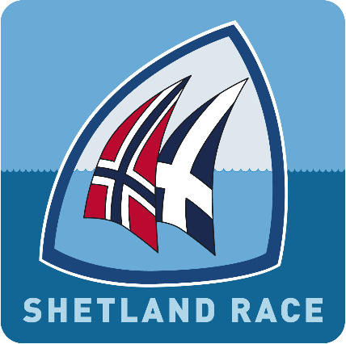 Shetland Race 2022

Declaration form - Position reporting and finishing line

This declaration must be filled out by all yachts and be delivered as described in the Sailing Instructions.

Yachts not finishing the race shall follow the procedure as described in the Sailing Instructions.

Report immediately if you choose to retire from the race!

Yacht name: ______________________________

Sail number: ______________________

Skipper name: ______________________________

Leg: Bergen (Rongesund) - Shetland (Lerwick)
Note! All times to be given as Norwegian Daylight Saving Time (Norsk sommertid)

Reporting point | Yacht passed |  | Sign
 | Date | Time
Greenwich Meridian 0º | .06.2022 | (hrs:min)
4º East | .06.2022 | (hrs:min)
Finishing - Lerwick | .06.2022 | (hrs:min:sec)

I hereby declare to have skippered the yacht stated above during the Shetland Race 2022 and that all applicable rules and regulations were followed during the race.

Date:___________________ Signature: ___________________________

